2024 Nomination Form for VPPPA Region 1 Board of Directors

◊◊◊ Submission Deadline: March 22, 2024 ◊◊◊

Check here if self-nomination.
Nominated by signed: Title:
Seeking the Board of Directors position of:

Name: Company: Mailing Address: City, state and zip:
Phone number: | Fax Number:
E-mail:

Please check one of the following
Non-exempt salaried employee.
Exempt salaried employee.
Union employee
Jeff Stolz, Nominations Committee
VPPPA Region 1
c/o Raytheon Technologies
350 Lowell Street
Andover, MA. 01810
Phone: (978) 490-0765
Email: | Jeff.Stolz@RTX.com

A signed commitment letter from my supervisor is attached.
A bio summary is attached.

Signed: | Date:

This form must be returned by March 22, 2024. After receipt of this form, we will
e-mail or send a Nomination Acceptance Letter to the nominee.

If you wish to nominate yourself or someone else for a board position, please complete
this form and return it to:
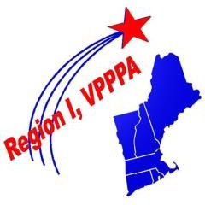
"The Best in the Northeast!"

