2018 VPPPA Region I Safety & Health

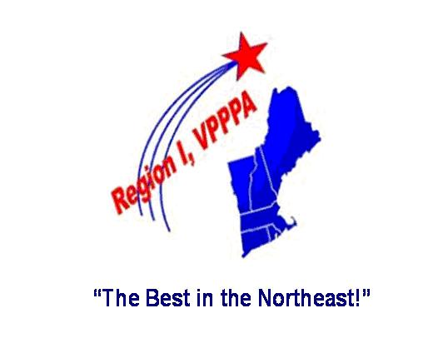
Excellence Conference & Exposition
S Sea Crest Beach Hotel (Cape Cod) May 7-9, 2018
Visit www.VPPRegion1.com for Conference Details
AGENDA (as of 2/13/18 – subject to change)
Monday, May 7 Registrations Open (7 a.m. – 5 p.m.)
Pre-Conference Workshop - VPP Application (8 a.m. – 3 p.m.), EHS Excellence Consulting
Pre-Conference Workshop – Strengthening Star Quality (1 – 3 p.m.), J.Popp - Cartamundi
Region 1 New England VPPPA Chapter Annual Business Meeting (4 – 5 p.m.)
Reception at Exhibit Hall opening (5 – 6 p.m.)
Region 1 VPPPA Awards Dinner (6 – 8 p.m.)
Tuesday, May 8 Registrations Open (7 a.m. – 5 p.m.)
Opening General Session (8 – 9:15 a.m.), Keynote Speaker – Bob Veazie of People Powered Leadership (Personal Commitment – Gaining, Sustaining, and High Performance)
Exhibit Hall Open (9:15 a.m. – 2:30 p.m.)
Breakout Sessions (9:45 – 10:45 a.m.)
- OSHA Region 1 Update (T.Irving - OSHA)
- The New Face of Hazcom – SDS & Label Compliance (C.Haling – VelocityEHS)
- Ishikawa Root Cause Analysis: Preventing the Next Incident (M.Renouf – Cintas)
- Believe it or Not–you can fit test Hearing Protection (J.Weaver, J.Caulfield -Raytheon)
- Vermont VPP Best Practices (K.Hayden – OSHA, VT VPP )
Breakout Sessions (11:15 a.m. – 12:15 p.m.)
- Safer Chemical Alternatives (Steve Gauthier – Gauthier Safety)
- Survive an Active Shooter (EHS Excellence Consulting Team)
- When Good Machines Go Bad, Lessons Learned on Metalworking Fluid Management (A.McCormack, M.Castle – Raytheon)
- Annual Self-Evaluation Best Practices (D.Irish – FLEXcon, B.Sullivan – OSHA)
- Improving Employee Ownership and Leadership Behaviors for Safety Culture Excellence (B.Veazie – People Powered Leadership)
Conference Luncheon (12:15 – 1:30 p.m.) OSHA Region 1 Awards (B.Sullivan – OSHA)
Breakout Sessions ( 1:30 – 2:30 p.m.)
- Using Facts & Data to Identify Cost Effective Ergonomic Solutions (B.Zavitz – Ergo Human Performance)
- Tough Love or Tough Talk – Turning our Safety Discussions into Win/Wins (J.Stolz, S.Gonzalez, A.Fitzgerald, M.Marucci, E.Cohen - Raytheon)
- Survive the Local Fire Inspection (EHS Excellence Consulting Team)
- Best Practice in Hearing Conservation (H.Freed, A.Hengen – Industrial Hearing Testing)
- Maintenance Employees, Shop and Garage Safety (A.Palhof – OSHA)
Wellness Break (2:30 – 5 p.m.) – Enjoy Sea Crest and Cape Cod activities during this break.
Conference Dinner (5 p.m. start) followed by Entertainment (Musician Frank Serafino)
Wednesday, May 9 Exhibit Hall Open (7 – 11 a.m.)
Breakout Sessions (8:30 – 9:30 a.m.)
- Labor - Management National Update (Bruce Gove - UTC)
- Walking & Working Surfaces Standard Update (L.May - OSHA)
- Focus on the Risk Forest, not the Recordability Tree (T.Caty, K.Kearney - Raytheon)
- Realizing the Benefits of Contemporary Machine Safety Solutions (J.Drew – Rockwell)
- Risk Management/Behavior-Based Safety (R.Wobby – AGC of VT)

Closing General Session (10–11 a.m.), Speaker – Gary Higbee (Future of Workplace Safety)

