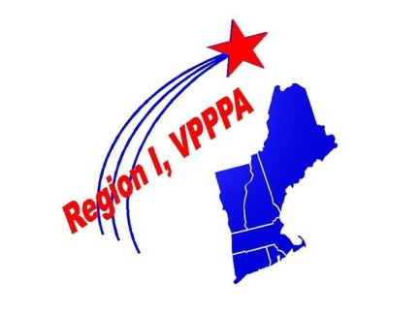
"The Best in the Northeast!"

Management Letter of Commitment
For Nominee for VPPPA Region 1 Board of Directors

Dear VPPPA Region 1 Nominating Committee :

I support the commitment level set forth in sections 2.5 and 2.6 (meetings) of Region 1 VPPPA By-laws especially as it relates to travel costs, and time away from work, and support of _________________________________________ to run for the position of

____________________________________________________________________

for the length of the subject position term.

I understand that this site commitment is required for BOD eligibility.

Sincerely,

________________________________
Manager’s Printed Name Title

________________________________________ ______/_____/_______
Manager’s Signature & Date

