2017 VPPPA Region I Conference

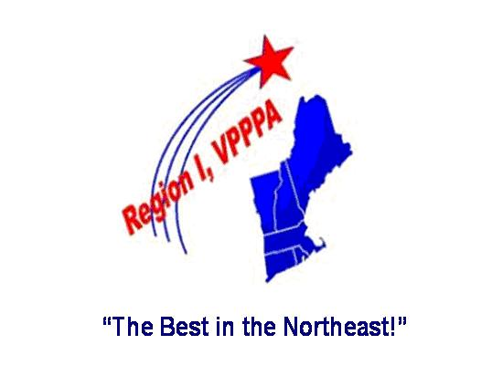
Killington, VT on May 15 - 17, 2017
Visit www.VPPRegion1.com for Conference Details
AGENDA (as of 1/9/17 – subject to change)
Monday, May 15 Registrations Open (7 a.m. – 5 p.m.)
Pre-Conference Workshop - VPP Application (8 a.m. – 3 p.m.), EHS Excellence Consulting
Pre-Conference Workshop – (8 a.m . – 4 p.m., ) Federal Mediation & Conciliation Service
Pre-Conference Workshop – Magical Moment of Employee Engagement (1.- 3 p.m.), Raytheon
Region 1 New England VPPPA Chapter Annual Business Meeting (4 – 5 p.m.)
Reception at Exhibit Hall opening (5 – 6 p.m.)
Region 1 VPPPA Awards Dinner (6 – 8 p.m.)
Tuesday, May 16 Registrations Open (7 a.m. – 5 p.m.)
Opening General Session (8 – 9:15 a.m.), Keynote Speaker – Josh Davis
Exhibit Hall Open (9:15 a.m. – 2:30 p.m.)
Breakout Sessions (9:45 – 10:45 a.m.)
- OSHA Region 1 Update (T.Irving - OSHA)
- Home Agent Workstation Safety & Ergonomics (S.McLellan, M.Aube – L.L.Bean)
- Improving Safety Culture through Risk Management (S.McKenna – Catamount Consulting)
- Training Power Burst (J.Stolz, S.Gonzalez - Raytheon)
- Green Mountain VPP Best Practice (D.Whipple - OSHA )
Breakout Sessions (11:15 a.m. – 12:15 p.m.)
- Improve Tracking of Injuries & Illnesses (A.Palhof – OSHA)
- Making Safety Simpler (P.Susca – Opx Safety)
- Stump the Safety Guy! Keeping it real. (R.Thornton – Raytheon)
- VPP SGE Roundtable (D.Irish-FLEXcon, J.Popp-Cartamundi, B.Sullivan-OSHA)
- Experiencing turbulence: the bumpy ride of developing a strong employee engagement program (GE Aviation team)
Conference Luncheon (12:15 – 1:30 p.m.)
Breakout Sessions ( 1:30 – 2:30 p.m.)
- Welding Hazards & Preventions (B.Sullivan – OSHA, R.Knowles – Bath Iron Works)
- Academic Approach to Ergo & Safety Training (Ergonomic Collaboration Group)
- Office Workers are from Venus, Mfg Workers are from Mars (E.Rasmussen, S.Wizst - Raytheon)
- Survive the OSHA VPP Evaluation (EHS Excellence Consulting Team)
- Improving Workplace Safety through Drug Testing (R. Ammons - Psychemedics)
Wellness Break (2:30 – 5 p.m.) – Enjoy Killington activities during this break.
Conference Dinner (5 p.m. start)
Wednesday, May 17 Exhibit Hall Open (7 – 11 a.m.)
Breakout Sessions (8:30 – 9:30 a.m.)
- Labor - Management Forum (S. Gauthier - GE, Bruce Gove - UTC)
- Workplace Violence (L.May - OSHA)
- OSHA Recordability – You Make the Call (C.Raspiller, A.Loiselle, P.Ward - Raytheon)
- Machine Guarding – Technology Update & What’s New (J.Perrotti – Fuss & O’Neil)
- Beware the Grim Reaper of Complacency (P.Furr – Roco Rescue)

Closing General Session (10 – 11 a.m.), Keynote Speaker – Randy Royall

