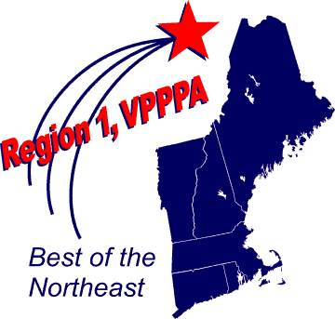Region 1 VPPPA Chapter Meeting February 7, 2017 (10am-3pm).
Lunch will be provided
71 Heater Rd, Lebanon, NH 03766
Over the next two months we’ll be drafting the agenda, for February’s first quarterly Chapter Meeting at Hypertherm in Lebanon, NH.
The topic will be “Industrial Robots, the Collaborative Robot System – Safety Requirements”. Currently, new standards and guidelines are being developed. Hypertherm will share their learning experience with collaborative robots. There will be several folk’s present with Robotics experience.
For nearly 50 years, Hypertherm’s objective has been to deliver the world’s finest cutting products and solutions that help give shape to our customers’ vision. Our entire team of Associate owners is inspired by you to help shape a positive future of innovation, partnership and community that is full of possibility.
Personal Protective Equipment Required, Glasses and Shoes

RSVP Required: David Kiser
Office: (603) 643-3441 x 1170
Dave.Kiser@Hypertherm.com

